Wong, Marvin Dale S. 11/12/2019

2ECE-A 31 ECE2112

Experiment 6

HANGAROO GAME

1. isWordGuessed

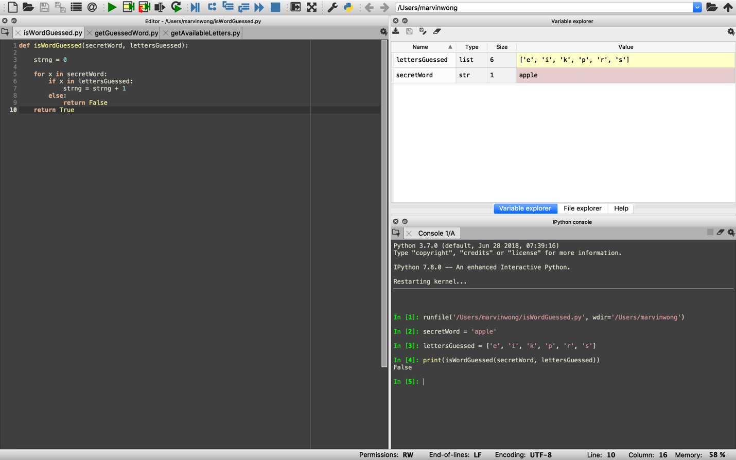

2. getGuessedWord

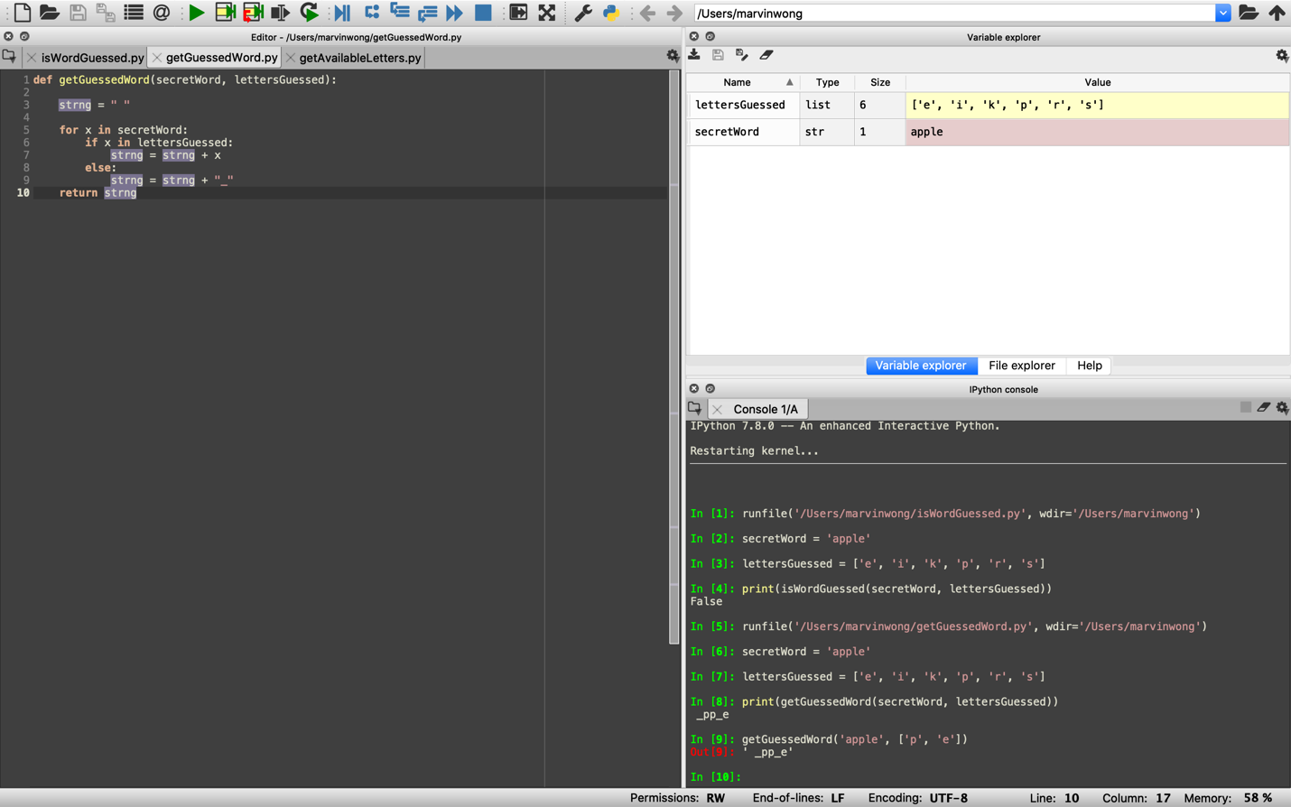

3. getAvailableLetters

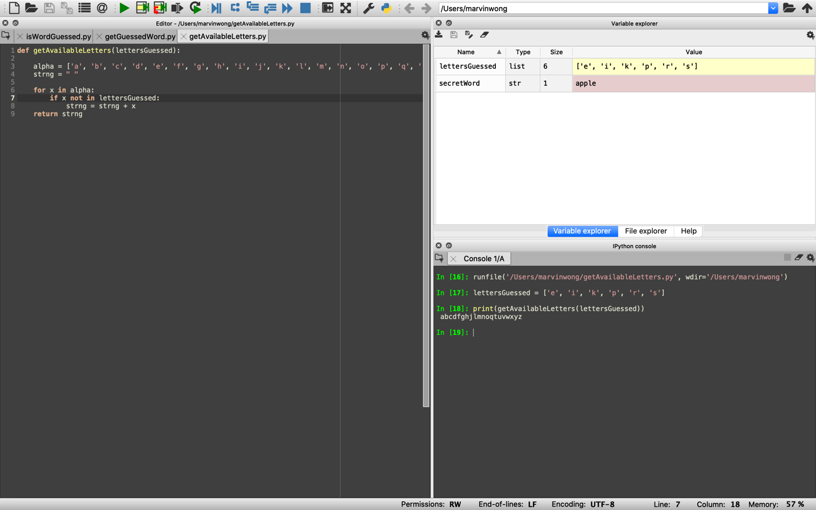

4. Hangaroo

